GENAI & AGENTIC AI ENGINEERING · DAY 3 · AFTERNOON LAB · BUILD BRIEF
AI Content Engine
One brief in → five creative assets out — text, image, and video from a single Streamlit app.
⏱ 120 minutes 🧰 Streamlit + OpenRouter + GPT Image + Runway 🚀 Start from scaffold 🎯 Multi-modal: text + image + video

WHAT’S NEW — THIS ISN’T PROMPT PRACTICE ANY MORE
Yesterday you perfected one prompt under an examiner’s eye. Today you wire five different AI calls into a single app — text generation (three calls), image generation, and video generation — all triggered by one button press. The prompt engineering skills from Days 1–3 power every call; the architecture from this morning’s Session 2 is the blueprint.
The scaffold handles layout and plumbing. Your entire two hours go into crafting the prompts, wiring the API calls, and making the output sing.

 | Prompt Doctor · Day 2 | AI Content Engine · Day 3
What you build | One prompt, graded by an AI examiner | A multi-modal Streamlit app that generates five assets
The hard part | The prompt — there’s nothing else | Orchestrating five different API calls + prompt engineering for each
Modalities | Text only | Text + Image + Video
Output | One polished prompt per level | A working app that produces a campaign suite

The two-hour mission
Every morning session today taught you a tool: multi-turn prompting, AI app architecture, image/video/audio generation. This lab is where you combine them. You’ll build a Streamlit app that takes a product brief (product name, target audience, brand tone) and generates a complete campaign content suite in one click:

📝 Campaign tagline — Few-shot prompting to match brand voice
📝 200-word blog introduction — Role-based prompting (content strategist persona)
📝 Social media post — Structured output with platform-specific character limits
🎨 Campaign hero image — GPT Image API (gpt-image-2) via the image prompt formula
🎬 8-second promotional video — Runway API — image-to-video with a motion prompt

Why five calls, not one
A single mega-prompt would try to do everything and do nothing well. Each call is tuned for one job with one technique — the same principle as the prompt pipeline from last night’s homework, now extended to images and video.

What it looks like
A Streamlit app with a sidebar input form (product, audience, tone) and a two-column main area (text assets on the left, visual assets on the right). One click generates everything.

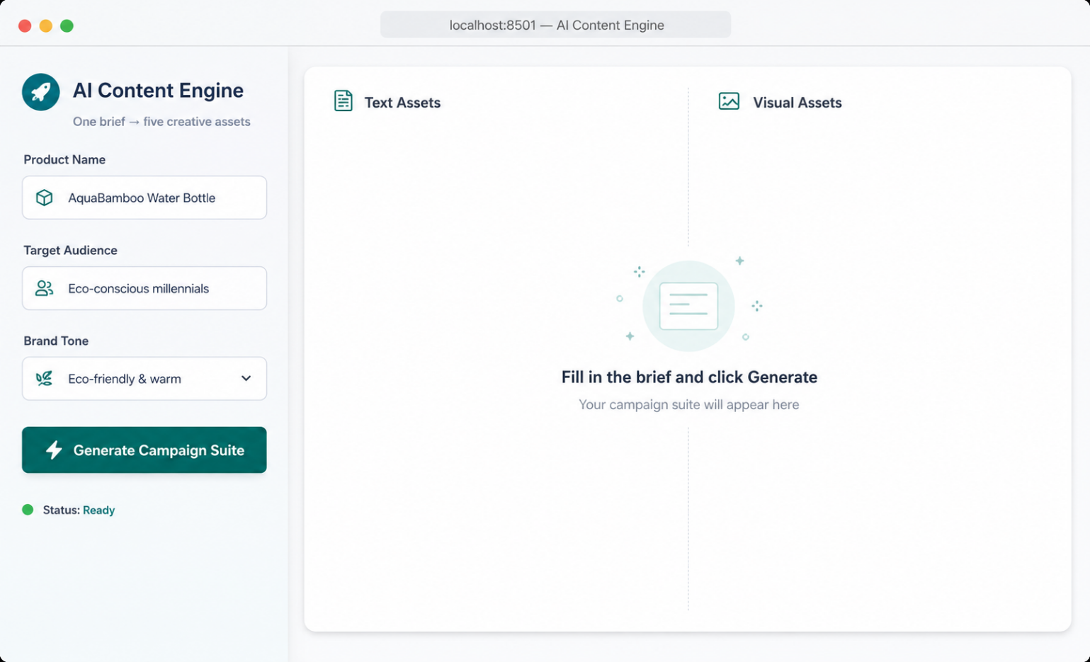
The input form: three fields, one button. The scaffold provides this layout — you build everything behind the Generate button.
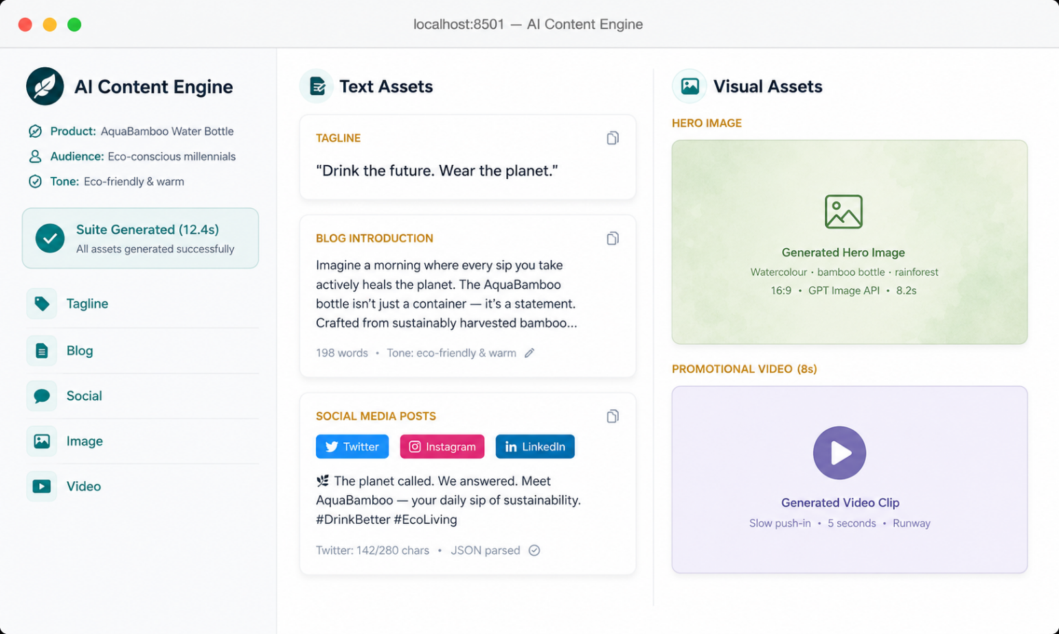
A complete run: tagline, blog intro, social posts, hero image, and video clip — all generated from a single product brief. Each card shows which technique powered it.
How the app works
One form, one button, five AI calls in sequence:
1. User fills the brief
Product name, target audience, brand tone — three input fields.
2. Text generation (3 calls)
Tagline (few-shot) → Blog intro (role-based) → Social post (structured output). Each runs in sequence; the tagline feeds into the blog intro’s context.
3. Image generation
The tagline + product name feed into an image prompt you construct using the Session 3 formula. One call to GPT Image API.
4. Video generation
The hero image feeds into Runway with a motion prompt. One call to Runway’s API. Result: an 8-second clip.
5. Display the suite
All five assets render on screen: text on the left, image + video on the right.
What’s provided · what you build
Provided scaffold: a Streamlit app shell with the input form, two-column output layout, the OpenRouter client, GPT Image API wrapper, Runway API wrapper, and placeholder functions.
You build: the five prompts (tagline, blog, social, image, video motion), the chaining logic, and any retry logic for API failures.

content_engine/
├─ app.py # Streamlit shell — provided
├─ text_gen.py # ← YOU BUILD: tagline, blog, social prompts
├─ image_gen.py # ← YOU BUILD: image prompt + GPT Image call
├─ video_gen.py # ← YOU BUILD: motion prompt + Runway call
├─ config.py # API keys + model settings — provided
└─ .env # OPENROUTER_API_KEY=... RUNWAY_API_KEY=...

The five prompts — the heart of the build
Each prompt is a distinct call with a distinct technique. The scaffold provides function signatures — you write the prompts inside.
Prompt 1 — Campaign Tagline (few-shot)
Use 2–3 few-shot examples to calibrate on tagline style. The brand tone from the input form controls which examples you inject.
# text_gen.py — tagline
TAGLINE_SYSTEM = """
You are a creative director. Generate ONE campaign tagline.
Match the brand tone exactly. Max 10 words. No hashtags.
"""

# TODO: build the few-shot examples based on {tone}
# TODO: user prompt = product + audience + tone
# TODO: call OpenRouter, return the tagline string
Prompt 2 — Blog Introduction (role-based)
Role: content strategist. The tagline from Prompt 1 feeds in as context. Exactly 200 words.
# text_gen.py — blog intro
BLOG_SYSTEM = """
You are a content strategist writing for {audience}.
Write a 200-word blog intro for {product}.
Weave in the campaign tagline: \"{tagline}\".
Tone: {tone}.
"""
Prompt 3 — Social Media Post (structured output)
Return JSON with per-platform variants: Twitter (280 chars), Instagram (2200), LinkedIn (700).
# text_gen.py — social
SOCIAL_SYSTEM = """
Generate social posts for {product}. Return ONLY JSON:
{ \"twitter\": string (max 280 chars),
\"instagram\": string (max 2200 chars),
\"linkedin\": string (max 700 chars) }
Tone: {tone}. No markdown fences.
"""
Prompt 4 — Hero Image (image prompt formula)
Construct the prompt programmatically: subject + style (from tone) + composition + constraints.
# image_gen.py
def build_image_prompt(product, tagline, tone):
style = {"playful": "bright flat illustration",
"premium": "photorealistic, studio lighting",
"eco": "watercolour, natural tones"}.get(tone, "clean modern")
return (f"A {style} of {product}. "
f"Centred, shallow DOF, 16:9. No text, no logos.")
Prompt 5 — Promotional Video (Runway motion prompt)
Feed the hero image into Runway with a gentle motion prompt. Keep duration at 5–8 seconds.
# video_gen.py
MOTION_PROMPT = ("Slow cinematic push-in. "
"Soft light shifts gently. "
"Background mostly still. 5 seconds.")

The chain matters
The tagline feeds the blog. The product + tagline feed the image prompt. The image feeds the video. Each output becomes the next input — same handoff pattern as your homework pipeline, now across modalities.

Stretch goals
Add a voiceover. ElevenLabs or OpenAI TTS from the blog intro.
A/B taglines. Generate two variants, let the user pick.
Tone switcher. Change tone, regenerate everything — watch the cascade.
Export suite. Package all assets into a downloadable ZIP.
Done by 3:00 means
• Your app generates all five assets in one run from a product brief.
• The tagline’s brand voice matches the tone. The blog echoes the tagline. Social posts respect character limits.
• The hero image matches the product and tone. The video is a clean 5–8 second clip.
• Peer review: a partner runs a different product through your engine and it holds up.

GenAI & Agentic AI Engineering · Student Programme · Day 3 Afternoon Lab — AI Content Engine

